1.Explain DAX.

 DAX is a collection of functions, operators, and constants that can be used in a formula, or expression, to calculate and return one or more values. Stated more simply, DAX helps you create new information from data already in your model.

2. Explain datasets, reports, and dashboards and how they relate to each other?

**A Power BI Dataset** is a series of Power Query queries that have been shaped in a DAX model. Each dataset can combine different files, database tables and online services all into one tabular model.  In our cookie analogy, these are all different “ingredients”.

Unlike SSRS, a dataset in Power BI does not represent a single table or query of data. A dataset should be considered more like a “flavor” of data used to accomplish a specific type of reporting: financial, operational, HR, etc. So in our analogy, the dataset is the “raw dough”.

So in Power Query, you are going to have a set of queries which each combine a data source with a usually linear set of transformations.

Then, in DAX, you are going to take each of those outputs and combine them into a model. This consists of defining relationships between the outputted tables and adding business logic via calculated columns and measures.

[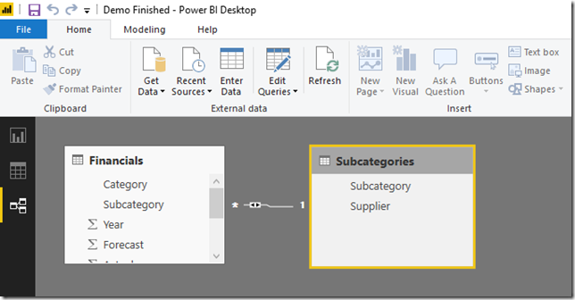](https://www.sqlgene.com/wp-content/uploads/2018/10/image-1.png)

For more on the difference between Power Query and DAX, see our previous episode of SQLChefs.

**A power BI report** is a series of visualizations, filters and static elements on a canvas. Power BI reports are saved as a single PBIX file and connect to a single dataset. Remember, a Power BI dataset can have many data sources.

[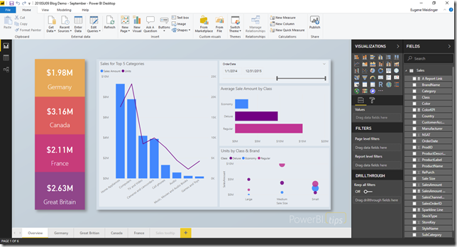](https://www.sqlgene.com/wp-content/uploads/2018/10/image-2.png)

Each report can have multiple sheets, just like an Excel workbook. In our analogy, this is us placing our “cookies” on multiple “cookie sheets” making one big batch, all of the same “flavor”.

### One report per dataset

A quick aside to something that used to confuse me. In most cases, a report and a dataset are going to have a one to one relationship. A dataset can have one report and a report can have one data set.

Recently this has changed, however. A while back, they added the ability to use an existing dataset as a data source for a report. and at Ignite they announced the ability to share datasets outside of the app workspace they were made in.

That being said, while you are still learning Power BI, it’s easier to remember that in many cases, your dataset and your report are going to have a one-to-one relationship and be tightly linked.

**In Power BI, dashboards** are a way of pulling together visualizations from various reports. When you think dashboard, you are probably thinking something like Microsoft’s definition: “A Power BI **dashboard** is a single page, often called a canvas, that uses visualizations to tell a story. Because it is limited to one page, a well-designed dashboard contains only the most-important elements of that story.”

However, if you look at the report example above, it probably fits that definition. It is not a Power BI Dashboard. In Power BI, a dashboard is tool for pinning visuals from different reports and other sources of data.

[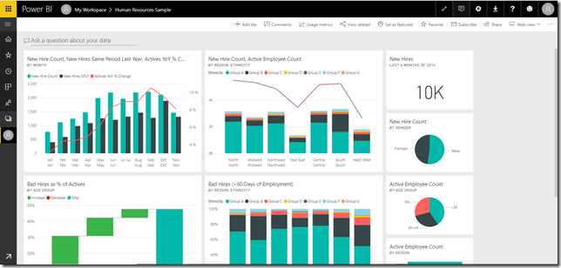](https://www.sqlgene.com/wp-content/uploads/2018/10/image-3.png)

In my opinion, a Power BI Dashboard is as much a tool for **organization** and **navigation**, as it is for actual reporting. I think that’s the real value add with Power BI dashboards.

3. How reports can be created in power BI, explain two ways with Navigation of each.

## Import the Excel file

This method of creating a report starts with a file and a blank report canvas. If you want to follow along, download the Retail Analysis sample Excel file and save it to your computer or to OneDrive for work or school.

1. In the navigation pane, select **My Workspace**.

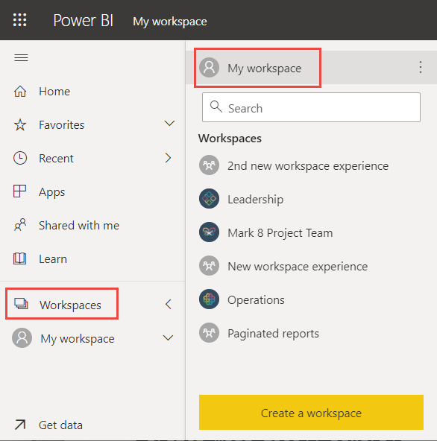

1. From the bottom of the navel pane, select **Get data**.

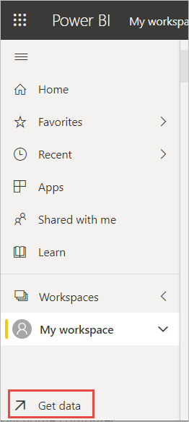

1. Select **Files** and navigate to the location where you saved the Retail Analysis sample.

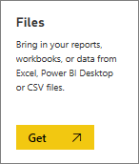

1. For this exercise, select **Import**.

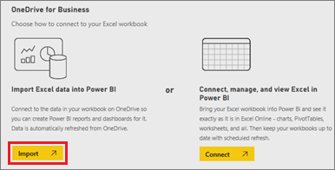

1. Select **Open**.

Once the Excel file is imported, it's listed as a dataset in the workspace list.

1. Select **More options (...)** next to the dataset, and select **Create report**.

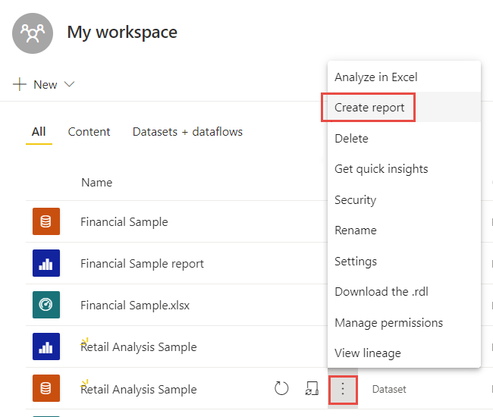

1. The report editor opens.

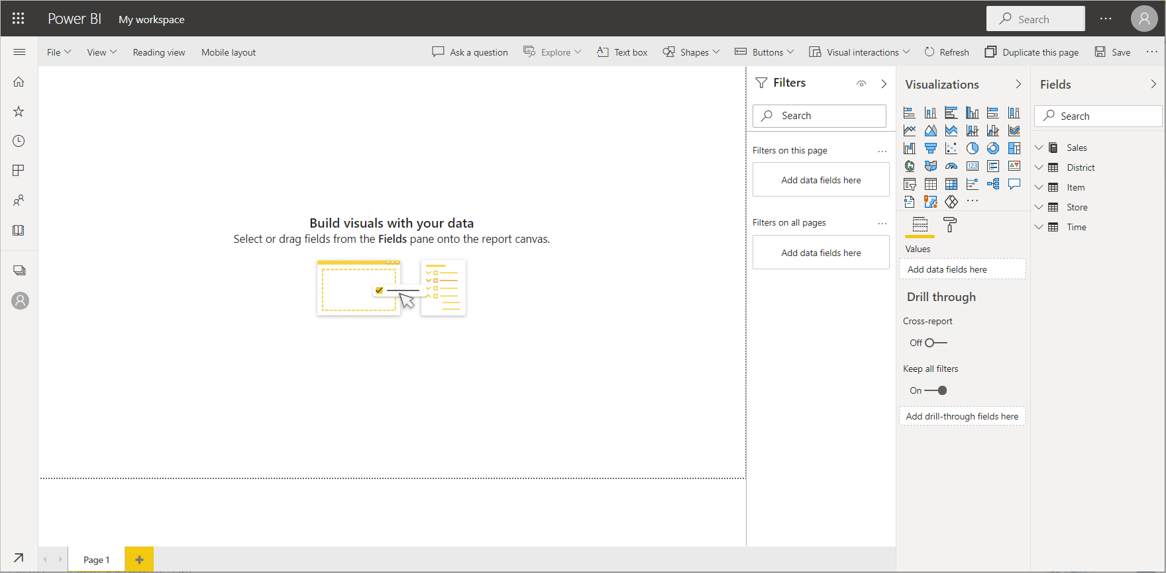

Select the menu icon to hide the navigation pane, to give you more room.

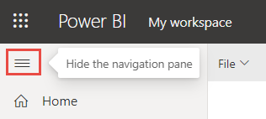

## Create a quick report

In the navigation pane in the Power BI service, you can select the **Create** button that opens a page where you can select your data source. It's also accessible from the **New report** button on Home.

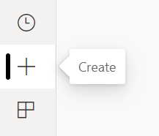

Currently, we only support creating a report based on an existing dataset or pasting or manually entering data directly in a table. Over time you'll see other options, such as uploading an Excel file.

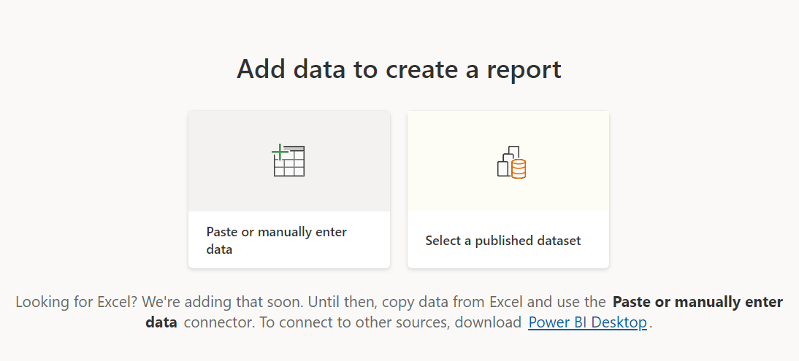

When you choose to paste or manually enter data, a grid appears that you can type into. You can also paste data by using Ctrl + V or the context menu.

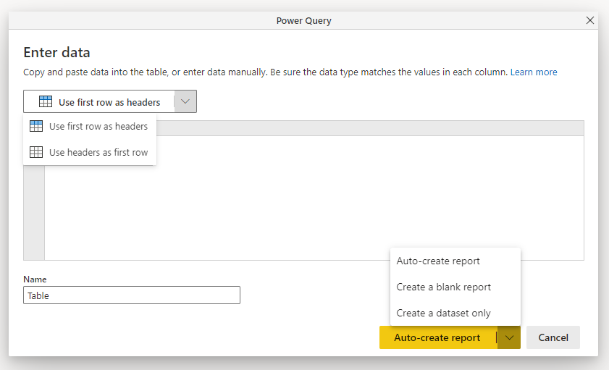

You can use the context menu to add and remove columns. If your pasted data includes a header row, select **Use first row as headers** to automatically promote the first row to the header row. Power BI automatically detects the data types, but you can set them manually. Select the **Data type** button next to the column name.

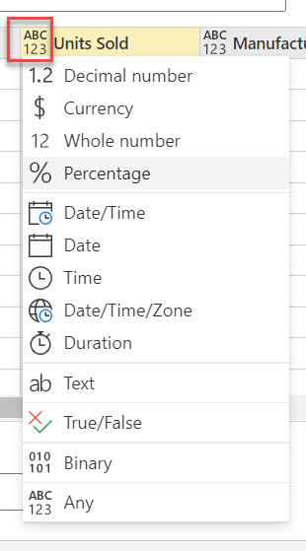

As you go through the creation process, Power BI creates a new dataset for you and auto generates a summarized view of your data. These auto generated visuals propel you from raw data to insights faster than ever.

[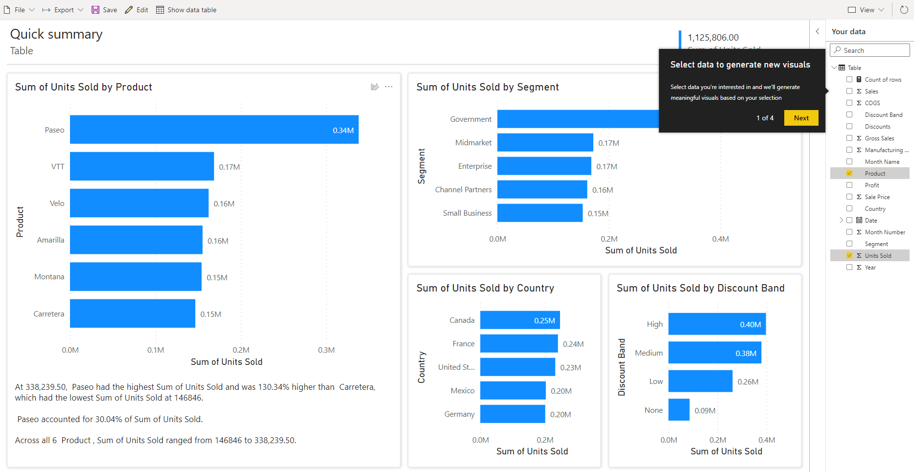](https://learn.microsoft.com/en-us/power-bi/create-reports/media/service-quick-create-report/select-data-fields-generate-new-visuals.png#lightbox)

Changing the data you see in the report is easy too. Use the **Your data** pane to add or remove fields from the report. Select and deselect fields to update what you want to measure and analyze. Power BI automatically plots meaningful charts based on your field selection.

4.How to connect to data in Power BI? How to use the content pack to connect to google analytics? Mention the steps

To connect to data, **from the Home ribbon select Get data**. The Get Data window appears. You can choose from the many different data sources to which Power BI Desktop can connect. In this quick start, use the Excel workbook that you downloaded in Prerequisites.

One can connect to Google Analytics data using the **Google Analytics** connector. To connect, follow these steps:

1. In **Power BI Desktop**, select **Get data** from the **Home** ribbon tab.
2. In the **Get Data** window, select **Online Services** from the categories in the left pane.
3. Select **Google Analytics** from the selections in the right pane.
4. At the bottom of the window, select **Connect**.  
   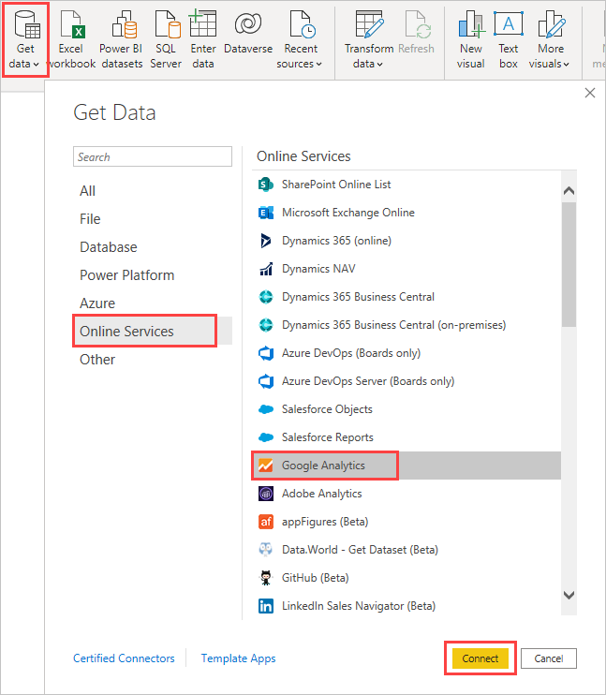

prompted with a dialog that explains that the connector is a Third-Party Service, and warns about how features and availability may change over time, and other clarifications.  
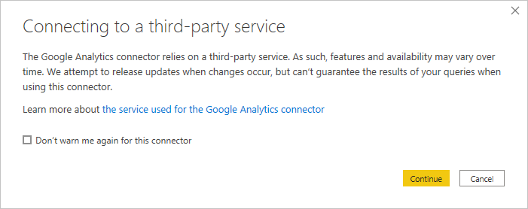

When you select **Continue**, you're prompted to sign in to Google Analytics.  
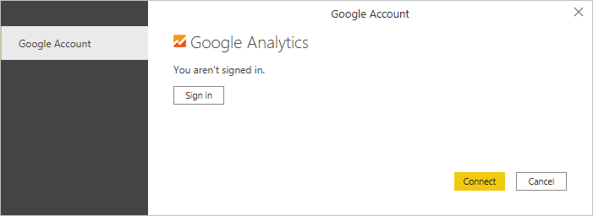

When you enter your credentials, you're prompted that Power BI would like to have offline access. This is how you use **Power BI Desktop** to access your Google Analytics data.

Once you accept, **Power BI Desktop** shows that you're currently signed in.  
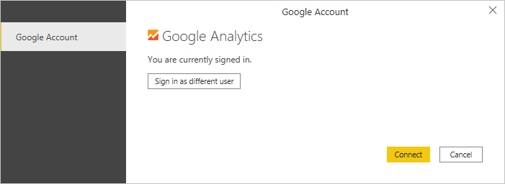

Select **Connect**, and your Google Analytics data is connected to **Power BI Desktop**, and loads the data.  
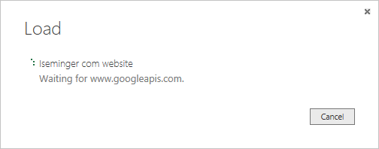

5.How to import Local files in Power BI? Mention the Steps.

**Import data to Power BI**

* In Power BI, click Get Data in the lower left screen.
* Under Import or Connect to Data > Files, click Get.
* Click Local File.
* Choose which file to upload and click Open.
* Click Upload under Upload your Excel file to Power BI.
* The message “Your file has been uploaded” should appear.

6.In Power BI visualization, what are Reading View and Editing view?

There are two modes for interacting with reports in the Power BI service: **Editing view and Reading view**. If one is a business user, then one is more likely to use Reading view to consume reports created by others. **Editing view** is used by report designers, who create the reports and share them with you. **Reading view** is a way to explore and interact with reports created by colleagues.

Even in **Reading view**, the content isn't static. One can dig in, looking for trends, insights, and other business intelligence. Slice and dice the content, and even ask it questions using your own words. Or, sit back and let the data discover interesting insights for you; send alerts when data changes, and email reports on a schedule you set. All the data, any time, in the cloud or on-premises, from any device.